

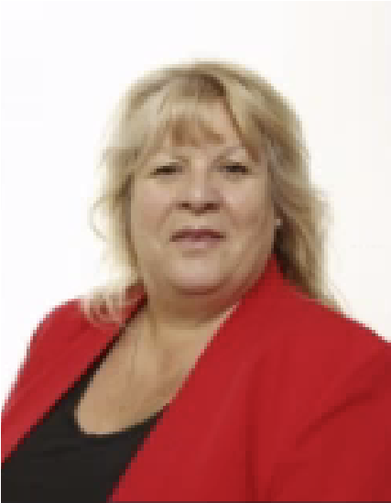

Safeguarding and Child

Protection

**‘WE ARE COMMITTED TO SAFEGUARDING AND PROMOTING THE**

**WELFARE OF CHILDREN AND YOUNG PEOPLE AND EXPECT ALL STAFF,**

**VOLUNTEERS AND OTHER THIRD PARTIES TO SHARE THIS**

**COMMITMENT.’**

We are one in Christ - Nos sumus unum in Christo

The safety of our students is our number one priority. Any

concerns or signs of abuse or neglect must be immediately

reported to one of our Designated Safeguarding leads (DSL)

Designated Safeguarding Lead

Mr. S. Lucraft

Deputy Safeguarding Lead

Mr. N. Pauro

Deputy Safeguarding Lead

Ms. A. Armstrong

Deputy Safeguarding Lead

Miss P. Ellis

Deputy Safeguarding Lead

highlighting the distinguishing aspects that set your school apart when it comes to promoting inclusivity. Up to a maximum of five minutes.

Mr. S. Page