# Safeguarding

This guide was created in conjunction with ‘Keeping Children Safe in Education 2024’ (KCSIE). It summarises key areas of concern and details how to go about reporting a concern.

# Visitors procedures

All visitors must sign in at Main Reception.

All visitors will be issued with an appropriate pass which must be displayed at all times whilst on the site.

Visitors will be asked to remain under the supervision of a designated member of staff whilst on site.

Visitors wishing to speak to a particular member of staff should telephone the school to make an appointment, when possible, to avoid disappointment.

If you are seeking an urgent appointment, please report to the Main Reception and we will arrange for you to see a member of staff on duty.

All visitors must sign out at the Main Reception and return their visitor pass before leaving the site.

Please refrain from using mobile phones on site as these pose a risk to students’ safety.

If you are concerned about the safety of any child in our school, you must report this to our **Designated Safeguarding Lead** – **Mr Lucraft.**

If you are concerned about the conduct of a member of staff or volunteer in our school, you must contact the **Headteacher – Ms Cantle.**

***“One in Christ”***

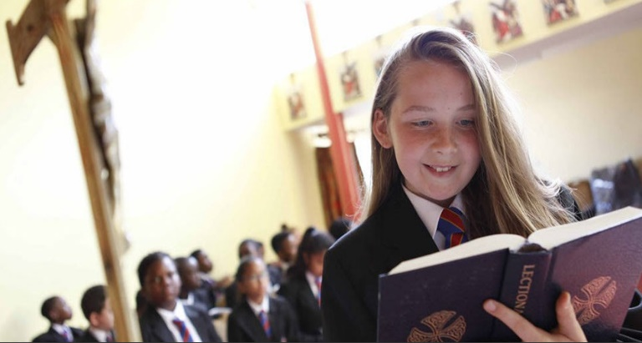

# Safeguarding Team:

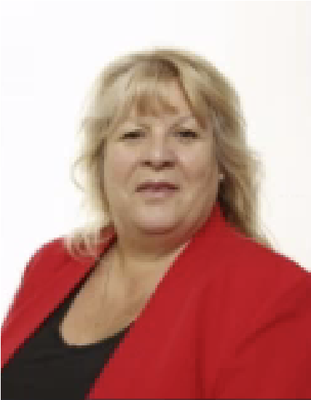Mr Lucraft Mr Pauro Ms Armstrong

**Visitors Safeguarding Guide**

All Saints Catholic School is committed to safeguarding and promoting the welfare of children and requires all staff, volunteers and visitors to share this commitment.

This leaflet contains information about our expectations of you whilst visiting the school. Please ensure your conduct reflects the school ethos and values.







# Keeping yourself and children safe

Be professional. Be careful how you interact with or speak to a child, the child may interpret it differently.

Avoid physical contact with children unless you are preventing them from immediately harming themselves or others.

Avoid being on your own with a child, always ensure that a door is open and that you are visible to others.

It’s best not to do anything for a child that he or she can do for him or herself.

Always tell someone if a child touches you or speaks to you inappropriately. Log down the incident, time and date it and pass it on to the Headteacher.

If you have any concerns about the conduct of staff, it is your responsibility to inform the Headteacher.

Remember … if in doubt … ask a member of staff.

# Types of harm

# Everybody has a responsibility to keep all children under the age of 18 safe and applies to both the home and school environment. Harm is identified in four ways:

# Physical – This is when a child is deliberately hurt or injured.

# Sexual – This is when a child is influenced or forced to take part in a sexual activity. This can be a physical activity or non-physical, e.g. being made to look at an inappropriate image.

# Emotional – This is when a child is made to feel frightened, worthless or unloved. It can be by shouting, using threats or making fun of someone. It can also be when children see their parents, or visitors to the home, fighting or using violence.

**Neglect** – This is when a child is not being taken care of by their parents. It can be poor hygiene, poor diet, not keeping appointments for additional support, not coming to school or being left home alone.



# Safer Behaviors

When visiting the school site, we expect you to be governed by and embody the school ethos and fundamental British values.

**Respect** – We respect every person’s innate human dignity as we are all created in the image and likeness of God and as such, we are one in Christ

**Understanding** - We understand that we achieve our best when we work together. We understand each other’s rights to human liberty and democracy.

**Affection** - We show one another affection by treating each other in the way we would like to be treated.

**Humour** – We work on managing our emotions and are considerate about how we make others feel.

# What Do I do if a child discloses, they are being harmed?

# React calmly. Listen carefully to the child, particularly what is said spontaneously.

Do not promise confidentiality. Explain to the child that you may need to pass on the information if you are worried about their safety.

You may clarify your concerns using “tell, explain, describe or outline” but as soon as your concern is confirmed, ask no further questions as further enquiries may be compromised.