Pupil premium strategy statement: All Saints Catholic School

This statement details our school’s use of pupil premium funding to help improve the attainment of our disadvantaged pupils.
It outlines our pupil premium strategy, how we intend to spend the funding in this academic year and the outcomes for disadvantaged pupils last academic year.

School overview
Detail | Data
Number of pupils in school | 1352
Proportion (%) of pupil premium eligible pupils | 21.45% (290)
Academic year/years that our current pupil premium strategy plan covers (3-year plans are recommended – you must still publish an updated statement each academic year) | 2025 – 2028
Date this statement was published | September 2025
Date on which it will be reviewed | September 2026
Statement authorised by | Ms C Cantle
Pupil premium lead | Mr J Caddy
Governor / Trustee lead | Mr J Mudad

Funding overview
Detail | Amount
Pupil premium funding allocation this academic year | £344,300
Pupil premium funding carried forward from previous years (enter £0 if not applicable) | £ 0
Total budget for this academic year  If your school is an academy in a trust that pools this funding, state the amount available to your school this academic year | £344,300

Part A: Pupil premium strategy plan

Statement of intent
In keeping with the mission statement and character of All Saints Catholic School, all students are expected to ascend, and we never leave a student behind. Whilst we recognise the importance of qualifications in expanding the opportunities available to our students, we believe that education is about far more than academic success alone. Developing the whole person is rooted in our mission, and we are committed to ensuring that every pupil is supported to develop academically, socially, emotionally, morally and spiritually. We believe that every student has the capacity to succeed and should have ambitious and aspirational targets that challenge them to reach their full potential. Our commitment is to ensure that every pupil makes sustained progress towards these targets, regardless of their starting point or individual circumstances.
Our aspirational objectives for disadvantaged pupils are:
- Pupil Premium (PP) students demonstrating good progress and high attainment across the curriculum, including SEND and those who are the most able.
- The numbers of PP students being entered for and achieving the EBacc remains above national average.
- PP students meet or exceed targets at GCSE Maths and English.
- PP students have access to places to work before and after school and during the school day in study periods. This includes the use of technology for learning, computer, hardware, and data access, for classwork, homework, and to revise.
- PP students regularly take part in enrichment activities, visits, and school trips locally and nationally (thus bridging the cultural capital gap) commensurate with all learners.
- PP students are supported to apply for places in the sixth form and at university
Key principles for use of the Pupil Premium at All Saints Catholic School.
- PP funding is identified in the budget by the school and spending is clearly allocated for specific initiatives targeted for PP students.
- The school’s practice complies with the DFE’s recommendations where practical and considered in the best interests of the individual.
- Recent research and reports relating to the use of PP e.g. from DFE, Ofsted and wider academic papers are read, understood and used to inform future decisions about the use of PP funding and to ensure that funding is allocated to activities that are most likely to have an impact on improving achievement.
- The school reviews this policy on a systematic basis following the publication of examination results, IDSR and termly tracking SISRA analytic data to assess the impact and relative effectiveness of initiatives and interventions on student progress.
- The school ensures the Headteacher and a designated member of the senior leadership team have a clear overview of how the funding is being allocated and review data termly to monitor the outcomes and impact. This is also monitored termly by the School Business Manager and School Data Manager.
- The school never conflates eligibility of the PP with low ability – therefore focussing acutely on supporting our disadvantaged students to achieve outstanding academic progress. The key to student success is ensuring that all teaching is carefully planned to meet the differing needs of all learners, rather than relying on interventions.
- Where more support is needed, skilled teachers are allocated to teach intervention groups to improve Mathematics and English while support teachers who have a good record of raising attainment in those subjects are deployed to support targeted students.
- Teachers and other practitioners are aware of those students who are in receipt of the PP and play a full part in deciding which strategies and targeted interventions might be appropriate for individual students at core subject (academic) or panelling (pastoral) meetings in KS3, 4 and 5.
The projects set up by the school tackle a range of issues and variables, for example, attendance, behaviour, factors outside the school, professional INSET on PP pupils, effective teaching and learning, strong careers information, advice and guidance, literacy support, targeted support, good facilities for supported study, and further enrichment.

Challenges
This details the key challenges to achievement that we have identified among our disadvantaged pupils.
Challenge number | Detail of challenge
1 | To continue to address the attainment gap which, whilst closing year on year still exists between Pupil Premium and Non-Pupil Premium students
2 | To continue to address the challenge, that PP pupils take up co-curricular activities at the same rate in KS3, however at KS4 there is a slight disparity in uptake
3 | Closing the literacy and numeracy gap between PP and Non-PP students
4 | Technological disparity between PP and Non-PP students and the impact this can have on homework
5 | To continue to drive More Able PP outcomes, these have improved significantly, therefore the challenge is to maintain their outcomes being at least in line with Non-PP More Able outcomes.

Intended outcomes
This explains the outcomes we are aiming for by the end of our current strategy plan, and how we will measure whether they have been achieved.
Intended outcome | Success criteria
Continue closing the gap between lower ability PP pupil progress and attainment at Key Stage Three. | Eradicating progress and attainment gaps for middle and lower ability PP pupils. Measured through termly reviews of summative assessment data for pupils.
Closing the gap between disadvantaged pupils and non-disadvantaged pupils at the end of KS4 for the grade 5+ measure in English and Maths. | PP and non-PP students achieving results which reflect their prior attainment data without disparity between these 2 categories
Improving the reading ages for all pupils, particularly those from the PP and other disadvantaged categories. | Ensuring that PP and other disadvantaged pupils have reading ages commensurate with their ability levels and their non-disadvantaged peers.
Provide all PP pupils with access to and greater uptake of co-curricular activities thus improving cultural capital. | Further monitoring of PP pupil uptake of non-sport based co-curricular activities. Pupil data and pupil voice will reflect an increase in opportunities and uptake of PP pupils in out co-curricular activities.

Activity in this academic year
This details how we intend to spend our pupil premium funding this academic year to address the challenges listed above.

Teaching (for example, CPD, recruitment and retention)
Budgeted cost: £ 153,550
Activity | Evidence that supports this approach | Challenge number(s) addressed
Lesson observations and learning walks which focus on teaching and learning for all pupils but with a focus on PP students | EEF: Quality first teaching has the biggest positive impact on pupil outcomes | 1, 2, 3, 4 and 5
Use of school CPD programme to highlight PP and promulgate effective teaching and learning strategies | EEF: Quality first teaching has the biggest positive impact on pupil outcomes | 1, 2, 3, 4 and 5
Continued recruitment of Outstanding teachers | EEF: Quality first teaching has the biggest positive impact on pupil outcomes | 1, 2, 3, 4 and 5

Targeted academic support (for example, tutoring, one-to-one support, structured interventions)
Budgeted cost: £ 104,050
Activity | Evidence that supports this approach | Challenge number(s) addressed
Provision of literacy and numeracy throughout the school timetable | EEF guidance focused on Literacy and Numeracy development  Use of the 3:1 golden ratio for intervention | 1, 2 and 3
The Brilliant Club provides PP students with high aspirations for university study and future destinations. | The Brilliant Club works across UK schools to support less advantaged students to access the most competitive universities. | 1, 2 and 3
Working with external groups such as LSME outreach programme and the EEF for numeracy and literacy development (Action Tutoring) | EEF guidance focused on Literacy and Numeracy development  Use of the 3:1 golden ratio for intervention | 1, 2, 3, 4 and 5

Wider strategies (for example, related to attendance, behaviour, wellbeing)
Budgeted cost: £ 53,000
Activity | Evidence that supports this approach | Challenge number(s) addressed
Funded trips for PP students to access. | The school allocates nominal funds accordingly to enable these barriers to be overcome to have parity of experience to that of all students. That may include allocating specific resources that enable students to attend school or to access school experiences based on the principles of equality and social justice. | 1, 2 and 3
Contingency fund (For example, shoes, uniform, emergency fund, revision books) | To support the day-to-day running of the school, our PP students and their families can experience varied barriers across the academic year. The school allocates nominal funds accordingly to enable these barriers to be overcome to have parity of experience to that of all students. | 1, 2, 3, and 4
Supporting pupils’ social, emotional and behavioural needs | To support students who struggle with social, emotional or behavioural needs, the school has access to trainee social workers, a family support worker and mentors; most students seen are PP; supported by the EEF’s guidance that students under PP are more likely to struggle socially and emotionally. | 1, 2, 3, and 4

Total budgeted cost: £ [£ 310,600]

Part B: Review of the previous academic year

Outcomes for disadvantaged pupils
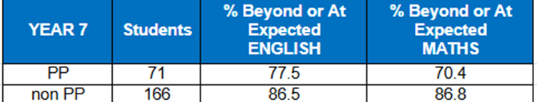

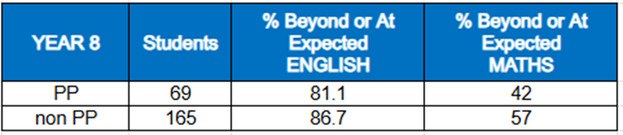

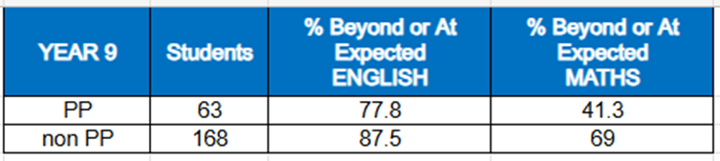
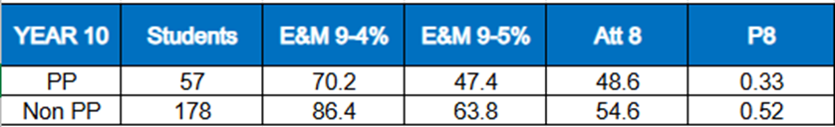
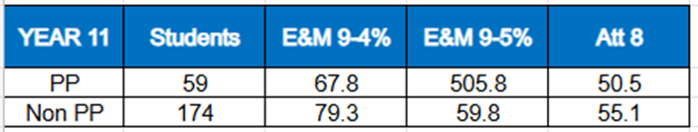

Externally provided programmes
Please include the names of any non-DfE programmes that you used your pupil premium to fund in the previous academic year.
Programme | Provider
n/a

Service pupil premium funding (optional)
For schools that receive this funding, you may wish to provide the following information: How our service pupil premium allocation was spent last academic year
The impact of that spending on service pupil premium eligible pupils

Further information (optional)
Use this space to provide any further information about your pupil premium strategy. For example, about your strategy planning, implementation and evaluation, or other activity that you are delivering to support disadvantaged pupils that is not dependent on pupil premium funding.

