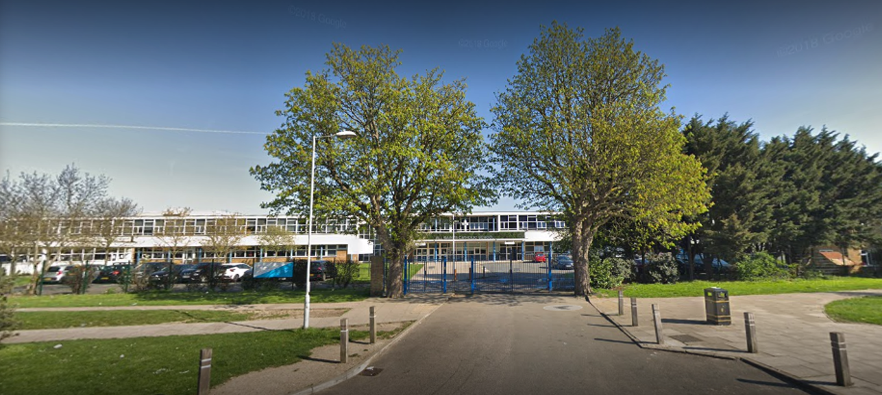

Cover Supervisor
Educating to truth, goodness and beauty.
Terling Road, Dagenham
RM8 1JT
Headteacher Ms Clare Cantle
Email: office@allsaintsschool.co.uk
Tel: 020 8270 4242
Fax: 020 8595 4024
JOB
OPPORTUNITY

School Mission Statement
We are all one in Christ, our mission and our responsibility is to recognise all individuals in our community as part of the body of Christ and to value them accordingly in our treatment of them, thriving and progressing in a spirit of togetherness.
(1 Cor. 12-29)
Role | Cover Supervisor
Closing Date for Application | Monday 2nd November
Required For | January start or earlier
Term | One Year
Salary | Scale 5 (point 12 £28,890)
Responsible for: | Providing cover/invigilation across the school

All applicants must complete a CES application form for this post.
School Information
All Saints Catholic School is an Outstanding Catholic comprehensive school situated in the London Borough of Barking and Dagenham and within the Diocese of Brentwood, with good transport links to central London.
All Saints Catholic School has over 1400 students from year 7 to 13. The school achieves excellent exam results, with a Progress 8 score of 0.72 (well above average) for 2024. We are also proud that we received the 2024 Pearson School of the Year for making a difference.
Our core values of Respect, Understanding, Affection and Humour underpin all aspects of our pastoral and academic daily routines. Our 2024 Ofsted judged us to be an Outstanding school, highlighting that “the school successfully encourages pupils to demonstrate its core values, which include respect and understanding others. In addition to this, pupils meet the school’s exceedingly high academic expectations and achieve very well”.
We have won a number of awards which reflect our inclusive approach to education, including being awarded the Rights Respecting Schools Gold Award and the Inclusion Quality Mark, this is indicative of our “One in Christ” motto that we apply every day to everyone that is a part of the school community.
Our learning is based on the transcendental values of truth, goodness and beauty. We encourage pupils to discover truth, develop a sense of goodness and appreciate beauty in the world around them.
Please watch our school videos available at: http://allsaintsschool.co.uk/ to get a further insight into life at All Saints.

Job description

Purpose of cover supervisor role:
• To uphold the Mission Statement of the School.
• To positively contribute to raising expectations and standards within the community.
• To promote a positive image of the School.
• To supervise whole classes to cover short term absence of teachers and to allow teachers to carry out professional duties and training. Cover supervisors will give instructions for the lesson, as provided by the teacher, and keep pupils on task while maintaining good order.

Key Responsibilities
Classroom Supervision
- Deliver pre-prepared work supplied by the absent teacher.
- Ensure students understand the tasks and remain focused throughout the lesson.
- Maintain a positive learning atmosphere that supports good behaviour and engagement.
- Manage classroom behaviour in line with school policies and behaviour management strategies.
- Ensure students follow the school’s expectations regarding conduct, uniform, and safety.
Learning Support
- Respond to students’ questions within the scope of the work set.
- Encourage independent learning and effective use of lesson time.
- Provide feedback to the teacher on student behaviour, engagement, or completed work as required.
Operational Duties
- Take attendance and record it accurately.
- Supervise students during non-teaching times when required (breaks, lunchtime, transitions).
- Assist in administrative tasks related to classroom management or cover.
- Support departmental staff with routine tasks when not covering lessons.
- Follow safeguarding procedures and report concerns promptly.
- Fulfil wider school professional duties such as exam invigilation and other reasonable Head teacher requests

Person Specification
Essential
- Good literacy and numeracy skills.
- Confidence managing the behaviour of young people.
- Strong communication and interpersonal skills.
- Ability to remain calm, professional, and consistent.
- Adaptability and flexibility when dealing with changing schedules.
Desirable
- Experience working with young people (e.g., school, youth work, tutoring).
- Knowledge of the secondary curriculum.
- Interest in pursuing a career in teaching or education.

Safeguarding
The post holder is responsible for promoting the welfare and safeguarding of children and young people and must adhere to all school safeguarding policies. An enhanced DBS check is required.

APPLY NOW

